COGNIZANT DIGI NURTURE 4.0
WEEK 8 MANDATORY HANDS ON
GIT- HOL

Fileno 1:

Objectives

Familiar with Git commands like git init, git status, git add, git commit, git push, and git pull.

In this hands-on lab, you will learn how to
- Setup your machine with Git Configuration
- Integrate notepad++.exe to Git and make it a default editor
- Add a file to source code repository
Step 1 – Git Configuration
1. Verify Git installation
git --version
Output:
git version 2.xx.x.windows.x
2. Configure your Git username and email
git config --global user.name "Uthayabi"
git config --global user.email "uthayabi77@gmail.com"
3. Verify configuration
git config –list
Output:
user.name=Uthayabi
user.email= uthayabi77@gmail.com

Step 2 – Integrate Notepad++ as Default Editor
1. Check if Notepad++ opens
notepad++
2. Create alias for Notepad++
alias np='notepad++'
3. Configure Git to use Notepad++
git config --global core.editor "'C:/Program Files/Notepad++/notepad++.exe' -multiInst -nosession"
4. Verify default editor
git config --global -e

Step 3 – Create GitDemo Project & Add File
1. Create a new directory and initialize Git
mkdir GitDemo
cd GitDemo
git init
Expected Output:
Initialized empty Git repository in C:/path/to/GitDemo/.git/
2. Verify hidden .git folder exists
ls -a
Expected Output:
. .. .git
3. Create a file and add content
echo "Welcome to Git Demo" > welcome.txt
4. Verify file creation
ls
Expected Output:
welcome.txt
5. View file content
cat welcome.txt
Expected Output:
Welcome to Git Demo
6. Check status
git status
Output:
Untracked files:
(use "git add <file>..." to include in what will be committed)
welcome.txt
7. Stage the file
git add welcome.txt
8. Commit the file (multi-line message in Notepad++)
git commit
9. Verify status
git status
Output:
nothing to commit, working tree clean

Step 4 – Push to Remote Repository
1. Link local repo to remote GitLab
git remote add origin https://gitlab.com/<uthayabi77>/GitDemo.git
2. Pull remote (if any changes)
git pull origin master --allow-unrelated-histories
3. Push local repo to remote
git push -u origin master
Output:
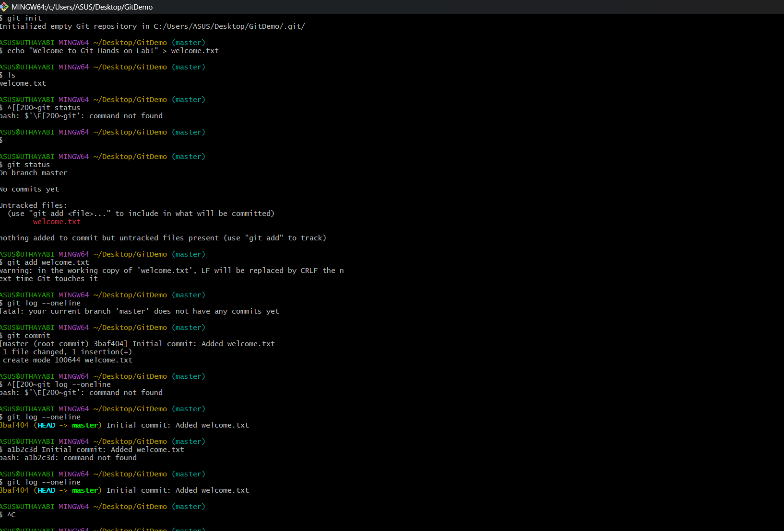

File no : 2

Objectives

Familiar with Git commands like git init, git status, git add, git commit, git push, and git pull.

In this hands-on lab, you will learn how to
- Setup your machine with Git Configuration
- Integrate notepad++.exe to Git and make it a default editor
- Add a file to source code repository

1.Open Git Bash and navigate to your working directory
cd ~/Desktop/GitDemo

2. Initialize Git (if not already initialized)
git init

3. Create a .log file and a log folder
touch test.log
mkdir log
touch log/file1.txt

4. Create or edit the .gitignore file
nano .gitignore
Add the following lines inside .gitignore:
*.log
log/

(Press CTRL + O → Enter → CTRL + X to save and exit if using nano)

5. Check Git status
git status
You should see that .log files and the log folder are not tracked.

6. Add and commit changes (only tracked files will be committed)
git add .
git commit -m "Added gitignore to ignore log files and log folder"

7. Verify ignored files again
git status

Output:
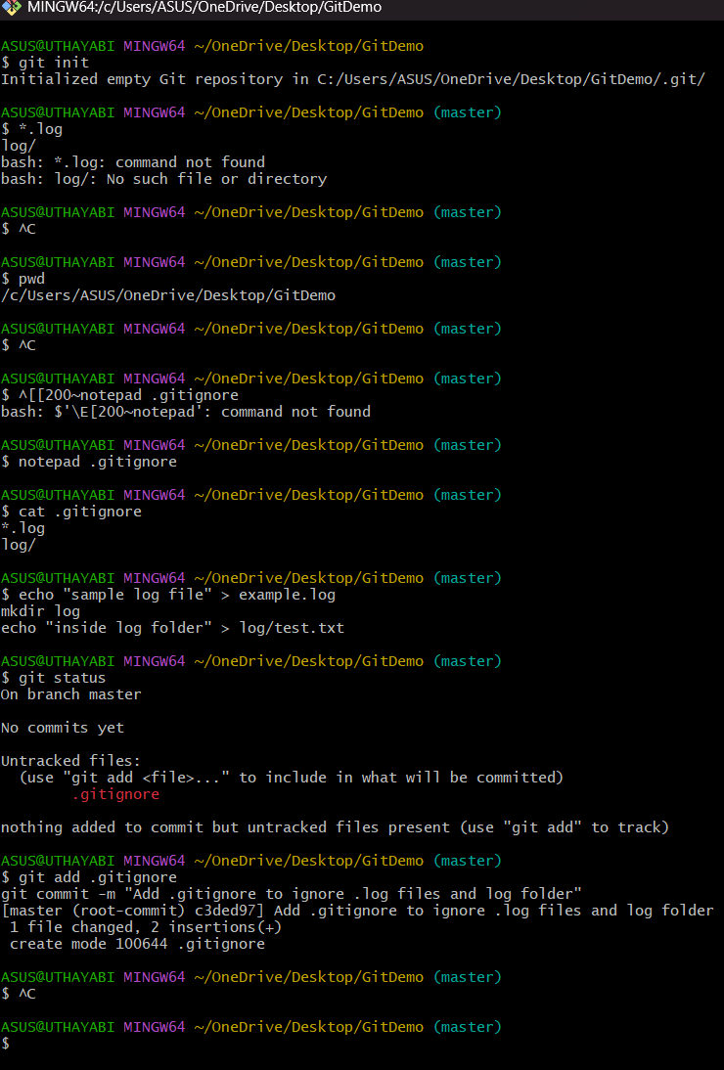
File no : 3
Objectives
Explain git ignore
Explain how to ignore unwanted files using git ignore
- Setting up Git environment
- Integrate Notepad++ as a default editor
- A Git repository in the local system and a remote repository in GitLab
Steps :
1. Open Git Bash in your working directory
cd ~/Desktop/GitDemo

2. Create a .log file and a log folder
touch sample.log
mkdir log
touch log/test.txt

3. Create a .gitignore file
touch .gitignore

4. Open .gitignore file in Notepad++
notepad++ .gitignore

5. Add the following entries to .gitignore
*.log
log/
Explanation:
- *.log → Ignores all .log files in the repository
- log/ → Ignores the entire log folder

6. Add .gitignore file to staging
git add .gitignore

7. Commit changes
git commit -m "Added .gitignore to ignore .log files and log folder"

8. Verify status
git status
You should see .log files and log folder not being tracked.

9. Push changes to remote repository
git push origin master
OUTPUT:
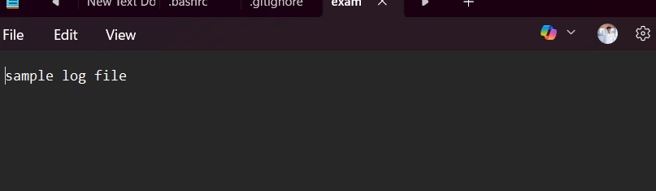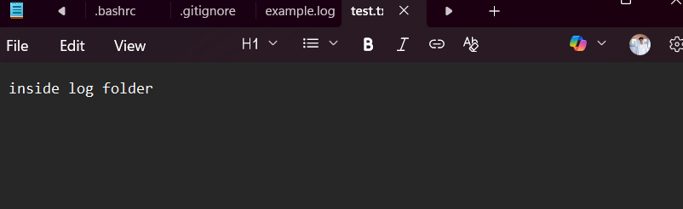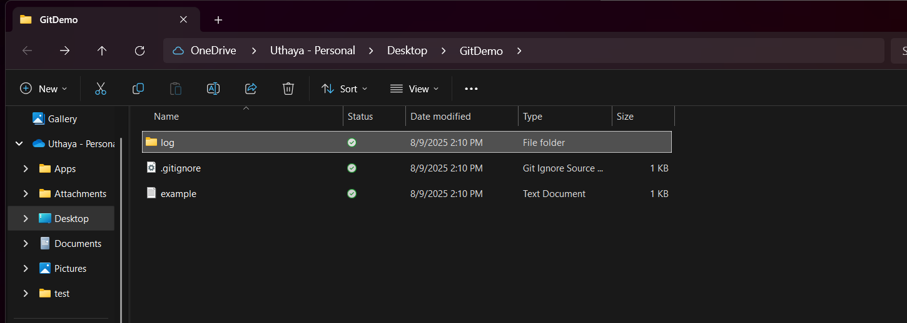
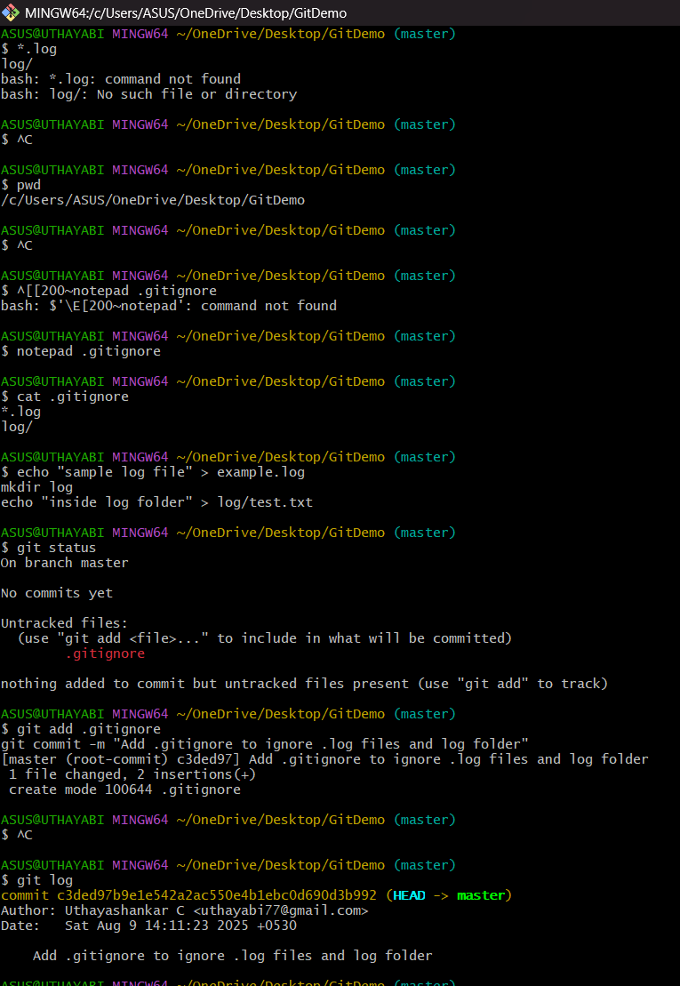

File no : 4
Objectives
- Explain how to resolve the conflict during merge.
- Hands-on ID: “Git-T03-HOL_001
Steps:
1. Verify if master is in clean state
git status

2. Create a branch “GitWork” and switch to it
git checkout -b GitWork

3. Add a file “hello.xml”
echo "<message>Hello from GitWork branch</message>" > hello.xml

4. Update the content of “hello.xml”
echo "<message>Updated content from GitWork branch</message>" > hello.xml
git status

5. Commit the changes in the branch
git add hello.xml
git commit -m "Added hello.xml in GitWork branch"

6. Switch back to master
git checkout master

7. Add a different version of “hello.xml” in master
echo "<message>Hello from master branch</message>" > hello.xml

8. Commit the changes in master
git add hello.xml
git commit -m "Added hello.xml in master branch"

9. Observe the commit history
git log --oneline --graph --decorate --all

10. Check differences between master and branch
git diff GitWork

11. (Optional) Use P4Merge tool for better visualization
p4merge

12. Merge the branch into master
git merge GitWork
At this step, a merge conflict will occur because both master and GitWork modified hello.xml differently.

13. Observe Git conflict markup in hello.xml
Open the file and you will see something like:
php-template
Copy code
<<<<<<< HEAD
<message>Hello from master branch</message>
=======
<message>Updated content from GitWork branch</message>
>>>>>>> GitWork

14. Resolve the conflict using a 3-way merge tool or manually
- Keep the desired content and remove the conflict markers (<<<<<<<, =======, >>>>>>>).

15. Mark the conflict as resolved and commit
git add hello.xml
git commit -m "Resolved merge conflict between master and GitWork"

16. Check Git status
git status

17. Add backup file to .gitignore
echo "*.orig" >> .gitignore
git add .gitignore
git commit -m "Added .gitignore to ignore backup files"

18. List out all available branches
git branch

19. Delete the merged branch
git branch -d GitWork

20. Observe final commit history
git log --oneline --graph –decorate

Output:

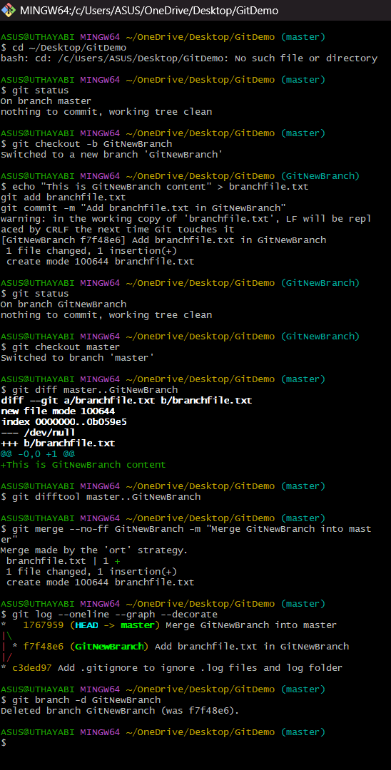

File no : 4
Objectives
Hands-on ID: Git-T03-HOL_002
Username: uthayasankar
Email: uthayabi77@gmail.com
Step:
1. Verify if master is in clean state
git status
- If it shows "working tree clean", your branch is already clean.
- If there are untracked or modified files, either commit them or discard:
git add .
git commit -m "Final commit before cleanup"
Or to discard changes:
git reset --hard
git clean -fd

2. List out all the available branches
git branch -a
- -a lists both local and remote branches.

3. Pull the remote git repository to the master
git checkout master
git pull origin master
- This ensures your local master branch is updated with the latest remote changes.

4. Push the changes from Git-T03-HOL_002 to remote repository
git push origin master
- This will push all local commits (from the previous lab “Git-T03-HOL_002”) to the remote master branch.

OUTPUT: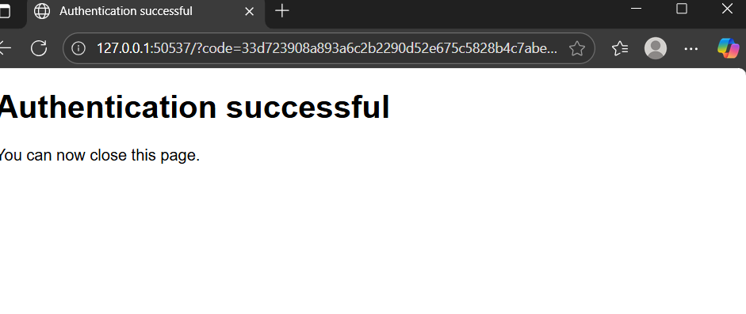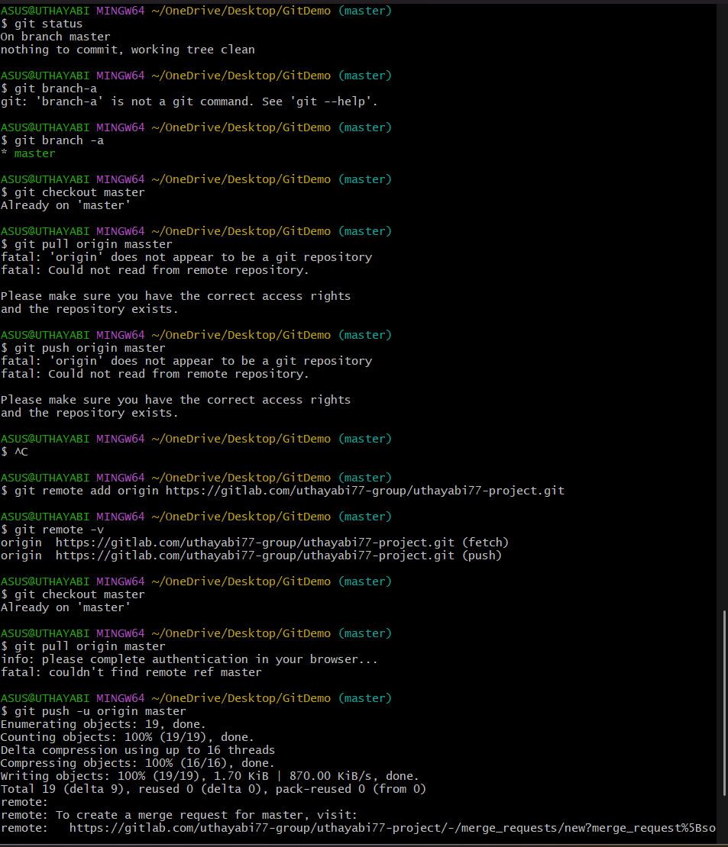
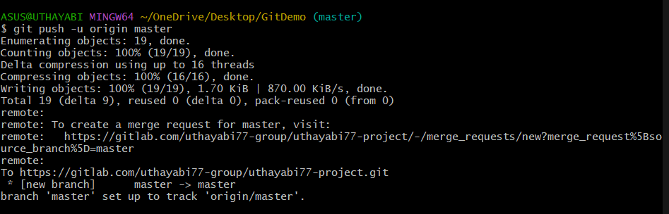

Completed by :
6377625

